Joint Press Release
1 April 2026

Nippon Express and Kansai Airports
sign MoU on strategic partnership

- Enhanced Collaboration to Position KIX as a Cargo Gateway for Western Japan -

Nippon Express Co., Ltd (NX), a group company of Nippon Express Holdings, Inc., and Kansai Airports (KAP) are pleased to announce the signing of a memorandum of understanding (MoU) for a strategic partnership.
This MoU is part of KAP’s “Cargo Next→” project, which aims to modernize the international cargo area of Kansai International Airport (KIX). Through this partnership, NX and KAP will leverage each other’s expertise and insight to bolster our collaboration to make KIX a gateway for Western Japan air cargo. We aim to make KIX an efficient, high-quality and sustainable hub for Western Japan air cargo through initiatives to consolidate cargo and enhance logistic efficiency such as organizing and expanding warehouse spaces.
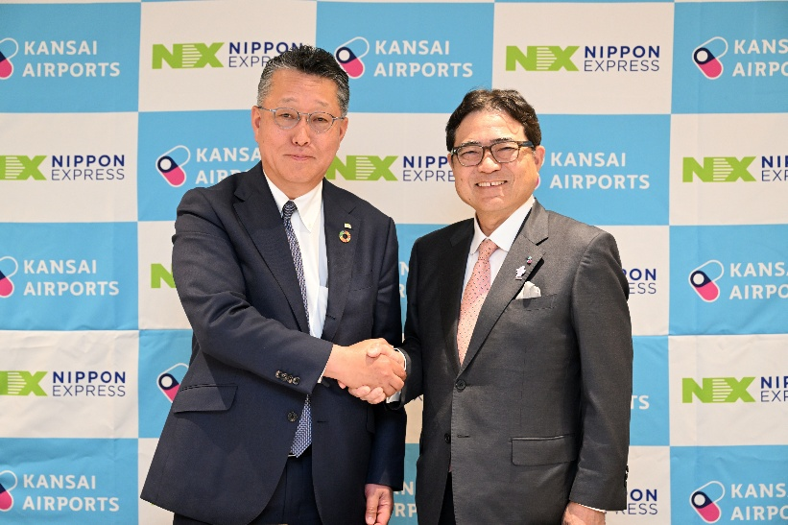

NX and KAP will strive to achieve higher efficiency in air cargo operations and enhance service quality with this MoU.
Contact for inquiries about this press release

■Nippon Express Holdings, Inc.
Corporate Communications Department
TEL: +81-3-5801-1212 Email: nxhd-pr@nipponexpress.com

■Kansai Airports
Group Corporate Communications Department
Email: pr＠kansai-airports.co.jp

